

myCPA@CLA

Review Materials Request – Committed Hire

Complete and submit this form to [MyPeopleSolutions@CLAconnect.com](mailto:MyPeopleSolutions@CLAconnect.com) to enroll in the myCPA@CLA program and request review materials.

|  |  |
| --- | --- |
| Committed Hire Information | |
| Name: | **Employee Number (if known):** |
| Office: | **Job Title:** |
| Personal Email Address: | **Anticipated Start Date:** |

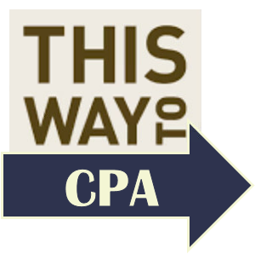

|  |  |
| --- | --- |
| Signature | |
| Name: | **Date:** |
| Electronic Signature: | |
| (Last name and last 4 numbers of your social security number) | |

CLAconnect.com

****WEALTH ADVISORY | OUTSOURCING | AUDIT, TAX, AND CONSULTING

Investment advisory services are offered through CliftonLarsonAllen Wealth Advisors, LLC,   
an SEC-registered investment advisor. CLA is an independent member of Nexia International,   
a leading, global network of independent accounting and consulting firms. See [nexia.com/member-firm-disclaimer](https://nexia.com/member-firm-disclaimer/).