The Security Update for Microsoft Windows (KB2962872) will cause the conversion utility to not perform as designed.
Please consult your IT Department before proceeding.

The current Microsoft status of this error is:
Link http://support.microsoft.com/kb/2962872/en-us
- Microsoft has confirmed that this is a regression that is introduced by the security update, and is working on a resolution. More information will be posted in this article when the information becomes available.
To remove the KB2962872 update, follow these steps:
* NOTE - The exact wording may vary based on your version of windows.

Navigate to Installed Updates:
(Start => Control Panel => Programs and Features => View Installed Updates)

In order to use the online conversion utility, this update must be removed thus removing the error that it introduced.

- Search for KB2962872
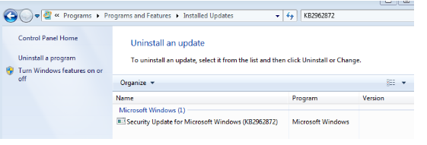

- Select row Security Update for Microsoft Windows (KB2962872) 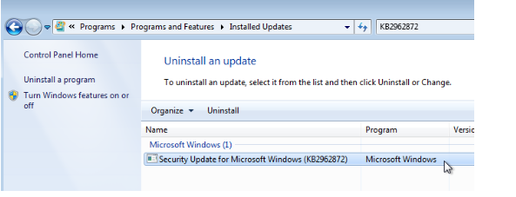
3. Uninstall the selected update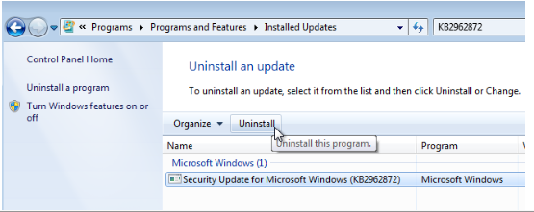
4. The system may require a reboot.

5. Afterwards:

This update is still currently available from Microsoft.
Should the PC be configured for automatic updates, it is likely that the KB2962872 update will be reapplied.
A solution is to add the update to the list of hidden updates so that it will not appear or be installed.

Example: After the update KB2962872 has been uninstalled, running a check for updates will show the KB2962872 as an important update.
(Start => Programs => Windows Update => Check for Updates)
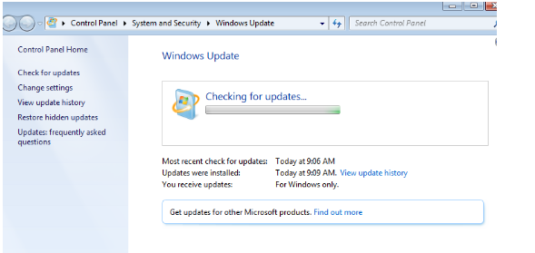

- When update check is finished, KB2962872 appears as an important update.
Click the “# important update is available” link to show the details.
*NOTE - In this example there’s only one.

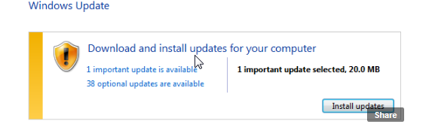

- Right click the KB2962872 update and choose hide update.

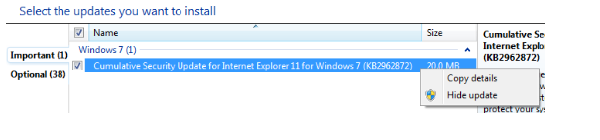
8. The KB2962872 important update is now hidden and will not be installed.
